## Front End Engineering-II

Project Report

Semester-IV (Batch-2022)

Title of the Project: -

THE-SPACIOUS

**Supervised By: Submitted By:**

Mr. Raveesh Samkaria Name: Suman Ranjan

Roll No: 2210990872 Group: G31

**Department of Computer Science and Engineering**

## Chitkara University Institute of Engineering & Technology,

## Chitkara University, Punjab

**Table of Contents**

|  |  |  |
| --- | --- | --- |
| **S. No.** | **Title** | **Page No.** |
| 1. | Introduction | 3 |
| 2. | Problem Definition and Requirements | 4 |
| 3. | Technical Details | 6 |
| 4. | File Structure | 7 |
| 5. | Code and Results | 11 |
| 6. | References | 48 |

**Introduction**

The React-Based Interior Design Furniture Project is an innovative web application aimed at revolutionizing how users engage with furniture and interior design. Leveraging the power and flexibility of React, a popular JavaScript library for building user interfaces, this project focuses on creating a dynamic, interactive, and user-friendly platform that enhances the experience of selecting and customizing furniture for interior spaces.

In the modern digital landscape, consumers increasingly seek immersive and personalized online experiences. Traditional e-commerce platforms often fall short in providing the interactive tools needed to visualize how furniture pieces will fit and look in real-life environments. This project addresses these gaps by incorporating advanced features such as 3D furniture visualization, interactive room planners, and real-time customization options.

React's component-based architecture plays a crucial role in this project, enabling the development of modular and reusable components that can be easily maintained and updated. These components ensure that the application remains scalable and adaptable to the evolving needs of users and the interior design industry.

Moreover, the project prioritizes a responsive design to ensure compatibility across various devices, including desktops, tablets, and smartphones, providing a seamless user experience regardless of the platform. Future enhancements, such as the integration of augmented reality (AR) and artificial intelligence (AI) technologies, are planned to further elevate the personalization and interactivity of the platform.

In summary, the React-Based Interior Design Furniture Project aims to set a new standard for online furniture shopping and interior design by delivering a robust, engaging, and user-centric platform. This project not only meets the current demands of consumers but also anticipates future trends, positioning itself as a leader in the digital transformation of the interior design industry.

**Objective:**

The primary objective of the React-Based Interior Design Furniture Project is to create an innovative web application that revolutionizes the online furniture shopping experience. This project aims to provide users with an intuitive, engaging, and highly interactive platform that facilitates the selection, customization, and purchase of furniture. By leveraging the power of Reacts component-based architecture, the project seeks to deliver a seamless and responsive user experience across various devices, ensuring that users can effortlessly visualize and plan their interior spaces with the furniture pieces of their choice.

A significant aspect of this objective is to enhance user engagement through advanced interactive features. The application will include 3D furniture visualization, allowing users to view products from multiple angles and get a realistic sense of how they will look in their homes. Interactive room planners and drag-and-drop functionalities will enable users to experiment with different layouts and configurations, providing a hands-on approach to interior design. Additionally, the project aims to integrate real-time data on product availability, pricing, and customization options, empowering users to make informed decisions quickly and efficiently.

Another key goal of the project is to streamline the operational workflow for both developers and users. By utilizing React’s modular and reusable components, the development process will be simplified, making it easier to maintain and update the application. The platform will also incorporate secure payment gateways and robust security measures to ensure user data protection and secure transactions. Future enhancements, such as the integration of augmented reality (AR) and artificial intelligence (AI), are planned to further personalize and elevate the user experience. Ultimately, the project aspires to set a new standard in the online furniture shopping and interior design industry, offering a comprehensive, user-centric solution that adapts to the evolving needs of consumers.

**Problem Definition and Requirements**

**Problem Statement**

In the current digital landscape, traditional online furniture shopping platforms often fall short in providing an engaging and interactive user experience. Customers frequently encounter difficulties in visualizing how furniture pieces will look and fit within their own spaces, leading to uncertainty and dissatisfaction with online purchases. The lack of intuitive tools for customization and room planning further exacerbates this issue, making it challenging for users to experiment with different layouts and configurations.

Moreover, existing platforms typically do not offer real-time updates on product availability, pricing, and customization options, which can result in frustration and missed opportunities for buyers. The static nature of these websites does not cater to the growing consumer demand for immersive and personalized shopping experiences. Additionally, developers face challenges in maintaining and updating these traditional platforms, which are often built using less modular and scalable technologies.

The React-Based Interior Design Furniture Project aims to address these problems by creating a dynamic and interactive web application that leverages the capabilities of React. By providing advanced features such as 3D furniture visualization, interactive room planners, and real-time data integration, the project seeks to enhance user engagement and satisfaction. This platform will not only streamline the shopping process for customers but also simplify the development and maintenance workflow for developers, offering a scalable and future-proof solution to the challenges faced by the online furniture shopping and interior design industry.

**Software Requirements**

**1. Node js and npm**

* Node.js: A JavaScript runtime built on Chrome's V8 JavaScript engine. It allows you to run JavaScript code outside of a browser.
* npm: The Node Package Manager, which comes with Node.js. It's used to install and manage packages (libraries and tools) needed for your project.

**2. Create React App:** A tool that sets up a new React project with a sensible default configuration. It simplifies the setup process and provides a modern build setup with no configuration.

**npx create-react-app my-app**

**3. Start app:** After completing react setup and installing react nodules and packages we can start our website using command -

**npm run dev**

**Technical Details**

The frontend website for the wedding destinations is powered by Vite-React and Tailwind CSS, two modern technologies known for their efficiency and flexibility.

1. **Vite-React:** Vite is a lightning-fast frontend build tool that significantly speeds up development by providing instant server startup and optimized production builds. Combined with React, a popular JavaScript library for building user interfaces, Vite-React allows for the creation of highly interactive and dynamic web applications. React's component-based architecture simplifies code organization and promotes reusability, making it easier to manage complex UI structures and maintain a consistent user experience.
2. **Tailwind CSS:** Tailwind CSS is a utility-first CSS framework that offers a pragmatic approach to styling web interfaces. Instead of writing custom CSS, developers can apply pre-defined utility classes directly to HTML elements, enabling rapid prototyping and efficient styling. Tailwind CSS's extensive utility classes cover a wide range of design needs, from spacing and typography to color schemes and responsive layouts. This approach promotes consistency and scalability, facilitating the creation of visually cohesive and responsive designs across different screen sizes and devices.
3. **Responsive Design:** The website is designed to be fully responsive, ensuring optimal viewing and interaction experiences across various devices and screen resolutions. Responsive design techniques, such as fluid layouts and media queries, are employed to adapt the website's layout and content dynamically based on the user's device characteristics. This ensures that the website remains accessible and functional whether accessed on a desktop computer, tablet, or smartphone, enhancing user engagement and satisfaction.

By leveraging Vite-React and Tailwind CSS, the frontend website for the creative agency benefits from efficient development workflows, streamlined styling processes, and enhanced performance. This technical stack empowers developers to create visually stunning and highly functional web experiences that effectively showcase the agency's brand identity and offerings.

**Proposed Design/ Folder Structure**

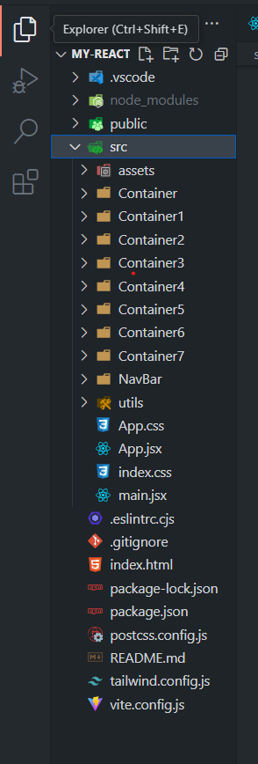

**1. Parent Folder : -**

* **node_modules:** This folder contains all the dependencies and packages installed via npm (Node Package Manager). These are defined in the package.json file and are necessary for the development and running of the project.
* **public:** This folder typically holds static assets that need to be served directly. It might include files like images, icons, and other resources that do not need to be processed by the build tool.
* **src:** This is the source folder where the main application code resides. It includes all the components, assets, Jsx, CSS, and other source files used in development.
* **.eslintrc.cjs:** Configuration file for ESLint, a tool used to analyze and ensure code quality and consistency. The .cjs extension indicates it uses the CommonJS module format.
* **.gitignore:** A file specifying which files and directories should be ignored by Git version control. Commonly used to exclude node_modules, build directories, and sensitive information.
* **index.html:** The main HTML file that serves as the entry point for the web application. It's typically referenced by the build tool to inject scripts and styles.
* **package-lock.json:** This file locks the versions of the dependencies installed via npm. It ensures that the project can be reproduced with the exact same dependency versions.
* **package.json:** A crucial file that contains metadata about the project, including dependencies, scripts, and other configurations. It is used by npm to manage the project's dependencies.
* **postcss.config.js**: Configuration file for PostCSS, a tool that processes CSS with JavaScript plugins.
* **README.md:** A markdown file that provides an overview of the project.
* **tailwind.config.js:** Configuration file for Tailwind CSS, a utility-first CSS framework. This file allows customization of the default Tailwind setup.
* **vite.config.js:** Configuration file for Vite, a modern build tool that provides fast development and optimized production builds. This file customizes Vite’s behavior.

**2. src Folder:-**

* **assets Folder:-** This folder is typically used to store images that your application needs.
* **components Folder:-** The components folder is used to organize your React components. These components are the building blocks of your React application and can be reusable UI elements.
* **App.css:-** This CSS file contains the styles specific to the App component. It’s common to have a separate CSS file for each major component to keep styles scoped and organized.
* **App.jsx:-** The App.jsx file is the main component of your application. It typically contains the root component and is often where the main application logic and routing are defined.
* **index.css:-** The index.css file contains global styles that apply to the entire application. This file is imported into the main entry point of the application to ensure that these styles are applied globally.
* **main.jsx:-** The main.jsx file is the entry point of your React application. This is where you render your App component into the DOM. In Create React App, this file is typically named index.js or index.jsx, but it can be named main.jsx as well.

**3.Components**: Each component is this folder contains a jsx file in which I have written the react code for that particular component.

* + NavBar : The React component responsible for rendering the content of the header Section.
  + Container: this includes page2 file for second page which displays information about website.
  + Container1 : this includes page3 file for third page which displays packages..
  + Container2: This includes page4 file for creating and styling fourth page of template.
  + Container3: This includes page5 file for creating and styling fifth page of template.
  + Container4: This includes page6 file for creating and styling sixth page of template.
  + Container5 : This includes page7 file for creating and styling seventh page of template.
  + Container6: This includes page8 file for creating and styling last page of template.
  + Container7 : This includes Footer of the website

**Snippets of Code**

import React from 'react'

import ReactDOM from 'react-dom/client'

import App from './App.jsx'

import './index.css'

ReactDOM.createRoot(document.getElementById('root')).render(

  <React.StrictMode>

    <App />

  </React.StrictMode>,

)

**main.jsx**

import { useState } from "react";

import "./App.css";

import Nav from "./NavBar/Nav";

import Box from "./Container/Box";

import Cont from "./Container1/Cont";

import Main from "./Container2/Main";

import OurStory from "./Container3/OurStory";

import Product from "./Container4/Product";

import Read from "./Container5/Read";

import New from "./Container6/New";

import Footer from "./Container7/Footer";

function App() {

  return (

    <>

**<div className="overflow-x-hidden overflow-y-hidden">**

        <Nav />

        <Box />

        <Cont />

        <Main />

        <OurStory />

        <Product />

        <Read />

        <New />

        <Footer />

      </div>

    </>

  );

}

export default App;

**App.jsx**

<!doctype html>

<html lang="en">

  <head>

    <meta charset="UTF-8" />

    <link rel="icon" type="image/svg+xml" href="" />

    <meta name="viewport" content="width=device-width, initial-scale=1.0" />

    <title>THE SPACIOUS</title>

  </head>

  <body>

    <div id="root"></div>

    <script type="module" src="/src/main.jsx"></script>

  </body>

</html>

**Index.html**

    @tailwind base;

    @tailwind components;

    @tailwind utilities;

    @layer utilities{

        .main{

            background-image: url("./Container1/layer.png");

            background-repeat: no-repeat;

            background-size: cover;

            height: 100vh;

            width: 100vw;

            margin-top: -8vh;

        }

        .story{

            /* background-image: url("./Container3/layer_17.png"); */

            background-image: url("./Container3/layer_18.jpg");

            background-size: cover;

            height: 100vh;

            width: 100vw;

        }

        .read{

            background-image: url("./Container5/layer_32.jpg");

            background-size: cover;

            height: 100%;

            width: 100%;

            margin-top: 4rem;

            /* filter: contrast(0.2); */

        }

        .read1{

            /* position:absolute; */

            content: '';

            width: 100%;

            height: 100%;

            background: rgba(255, 255, 255, 0.5);

            /* pointer-events: none; */

        }

        .line{

            background-image: url(./Container3/layer_17.png);

            height: 100%;

            width: 100%;

            background-size: cover;

        }

    }

**Index.css**

export default function Nav() {

  return (

    <>

      <nav className="bg-blue-900 text-white flex justify-around items-center h-[8vh] w-full m-0 p-2 text-[18px] ">

        <div>

          <h1 className="ml-[-2vw] ">www.elitedesignstudio.com</h1>

        </div>

        <div className="max-sm:hidden max-md:hidden max-lg:hidden">

          <ul className="flex justify-evenly items-center ml-[15vw]">

            <li>

              <a href="#Home">HOME &nbsp;+</a>

            </li>

            <li>

              <a href="#Service">&nbsp;&nbsp; SERVICE &nbsp;+</a>

            </li>

            <li>

              <a href="#Portfolio">&nbsp;&nbsp; PORTFOLIO &nbsp; +</a>

            </li>

            <li>

              <a href="#Read">&nbsp;&nbsp; READ BLOG &nbsp; +</a>

            </li>

            <li>

              <a href="#Contact">&nbsp;&nbsp; CONTACT &nbsp;+</a>

            </li>

            <li>

              <a href="#Support">&nbsp;&nbsp; SUPPORT</a>

            </li>

          </ul>

        </div>

      </nav>

    </>

  );

}

**` NavBar(Nav.jsx)**

import search from "../Container/image_3.png";

import twit from "../Container/te.png";

import fb from "../Container/fb.png";

import ig from "../Container/ig.png";

import yt from "../Container/yt.png";

export default function Box() {

  return (

    <div className="flex flex-wrap justify-center items-center mt-10 h-[40vh] gap-[24vw] max-sm:h-[60vh] max-sm:w-[100%]" id="Home">

      <div className="text-star mt-[-12em] max-sm:text-center max-sm:mt-[-2rem] ">

        <h1 className="text-gray-500 text-[48px] font-bold max-sm:text-[40px]">

          THE <span className="text-blue-800">SPACIOUS</span>

        </h1>

        <p className="text-gray-500 text-[20px] max-sm:mt-10">

          ONE OF THE BEST AND CLEANIEST <br />

          WORDPRESS THEME FOR AGENCIES AND <br />

          ONLINE PORTFOLIOS

        </p>

      </div>

      <div className="flex justify-center flex-col flex-wrap items-center mt-[-18vh] max-sm:mb-[8vh]">

        <div className="border-2 border-blue-700">

          <form className="flex justify-center items-center">

            <input

              className="example w-[24vw] h-[6vh] max-sm:w-[40vw]"

              type="text"

              placeholder=" Search for products"

              name="search"

            />

            <span className="w-10">

              {" "}

              <img src={search} alt="" height="25" width="25" />

            </span>

          </form>

        </div>

        <div className="flex mt-10 gap-5 ml-[6vw]">

          <h1 className="text-gray-500 text-[17px] italic">

            Follow us on Social Media

          </h1>

          <div className="flex gap-2">

            <span className="h-8 w-8">

              <img src={twit} alt="" height="25" width="25" />

            </span>

            <span className="h-8 w-8">

              <img src={fb} alt="" height="25" width="25" />

            </span>

            <span className="h-8 w-8">

              <img src={ig} alt="" height="25" width="25" />

            </span>

            <span className="h-8 w-8">

              <img src={yt} alt="" height="25" width="25" />

            </span>

          </div>

        </div>

      </div>

    </div>

  );

}

**Container(Box.jsx)**

export default function Cont() {

  return (

    <>

      <div className="main flex justify-between items-center max-sm:h-[80vh] max-sm:w-[100%]">

        <div className="h-[10vh] w-[5vw] bg-neutral-600 rounded p-7  flex items-center max-sm:hidden">

          <img src="src\Container1\image.png" alt="" height="25" width="25" />

        </div>

        <div className="flex justify-center items-center flex-col max-sm:text-center max-md:p-[1rem]">

          <div>

            <h1 className="text-[70px]  text-gray-700 max-sm:text-[50px] ">

              Welcome to the thespacious

            </h1>

          </div>

          <div>

            <h2 className="text-[50px]  text-gray-700 mb-12 max-sm:text-[40px] ">

              a furniture and interiors agency

            </h2>

          </div>

          <div className="flex gap-20 max-sm:flex-col max-sm:gap-8">

            <div>

              <button className="border-0 bg-white hover:bg-slate-200 border-black rounded-full text-[24px] p-4 w-[10vw] max-sm:w-[30vw] max-sm:text-[18px]">

                ABOUT

              </button>

            </div>

            <div>

              <button className="bg-blue-600 hover:bg-blue-400  border-0 text-white border-black rounded-full text-[24px] p-4 w-[10vw] max-sm:w-[30vw] max-sm:text-[18px]">

                GO SHOP

              </button>

            </div>

          </div>

        </div>

        <div className="h-[10vh] w-[6vw] bg-neutral-600 rounded p-9 flex items-center max-sm:hidden">

          <img src="src\Container1\copy_2.png" alt="" height="25" width="25" />

        </div>

      </div>

    </>

  );

}

**Container(Cont.jsx)**

import Left from "./Left";

import Cards from "./Cards";

export default function Main({ img }) {

  return (

    <>

      <div className="w-[100vw] h-[90vh] p-[4vw] flex justify-center items-center flex-wrap gap-[5vw] max-sm:w-[100%] max-sm:h-[100%]"  id="Service">

        <div className="leading-12" >

          <Left></Left>

        </div>

        <div className="text-center">

          <Cards></Cards>

        </div>

      </div>

    </>

  );

}

**Container1(Main.jsx)**

export default function Left() {

  return (

    <>

      <div className="flex flex-col  gap-10 text-gray-500 mt-[-14vh] max-sm:mt-[2vh] max-sm:text-center max-sm:items-center">

        <h1 className="text-blue-800 text-[35px] font-bold">

          FEATURED CATEGORIES

        </h1>

        <p className="w-[20vw] text-[24px]  leading-10 max-sm:w-[100%] max-sm:h-[100%] ">

          Lorem Ipsum is simply dummy text of the printing and typesetting

          industry. Lorem Ipsum has been the industry's standard dummy text

          <br />

          <br />

          ever since the 1500s, when an unknown printer took a galley ...

        </p>

        <button className="bg-blue-600 hover:bg-blue-400 border-0 text-white border-black rounded-full text-[22px] p-4 w-[15vw] mt-6 max-sm:w-[50vw] max-sm:text-[16px]">

          VIEW ALL CATEGORIES

        </button>

        <br />

      </div>

    </>

  );

}

**Container1(Left.jsx)**

import { items } from "../utils";

import Images from "./Images";

export default function Cards() {

  return (

    <div className="grid grid-cols-3 gap-[3vw] max-sm:grid-cols-1 max-sm:gap-4">

      {items.map((el) => {

        return (

            <div className="flex flex-col gap-4">

              <Images src={el.img}></Images>

              <h1 className="text-[20px]">{el.text}</h1>

          </div>

        );

      })}

    </div>

  );

}

**Container1(Cards.jsx)**

export default function Images({src}){

    return (

        <>

            <div>

                <img src={src} alt=""  height="300" width="330"/>

            </div>

        </>

    )

}

**Container1(Images.jsx)**

import Left from "./Left";

import Right from "./Right";

export default function OurStory() {

  return (

    <>

      <div className="story max-sm:h-[60vh]" id="Portfolio" >

        <div className="line flex justify-end items-center flex-wrap gap-[8vw] max-sm:h-[100%] max-sm:w-[100%] max-sm:text-black">

          <div>

            <Left></Left>

          </div>

          <div className="text-[28px] text-black bg-white opacity-65 w-[65vw] mt-[-10px] h-[65vh] text-right flex flex-row justify-evenly items-center max-sm:hidden">

            <Right></Right>

          </div>

        </div>

      </div>

    </>

  );

}

**Container3(OurStory.jsx)**

export default function Left() {

  return (

    <>

      <div className="flex flex-col gap-[4vh] mt-[-23em] max-sm:w-[100%] max-sm:h-[100%] max-sm:mt-4 max-sm:text-center max-sm:items-center ">

          <h1 className="text-[60px] text-white font-bold max-sm:w-[100%] max-sm:h-[100%]">OUR STORY</h1>

          <p className="text-[24px] text-white w-[20vw] max-sm:w-[100%] max-sm:h-[100%] max-sm:p-4">

            ONE OF THE BEST AND CLEANIEST WORDPRESS THEME FOR AGENCIES AND

            ONLINE PORTFOLIOS

          </p>

          <button className="bg-white hover:bg-slate-200 border-0 text-black border-black rounded-full text-[24px] p-4 w-[10vw] max-sm:w-[50vw] max-sm:text-[18px]">

            READ MORE +

          </button>

      </div>

    </>

  );

}

**Container3(Left.jsx)**

export default function Right() {

  return (

    <>

      <p className="w-[50vw] leading-[5vh] max-sm:h-[100%] max-sm:hidden">

        Lorem Ipsum is simply dummy text of the printing and typesetting

        industry. Lorem Ipsum has been the industry's standard dummy text ever

        since the 1500s, when an unknown printer took a galley of type and

        scrambled it to make a type specimen book. It has survived not only five

        centuries, but also the leap into electronic typesetting, remaining

        essentially unchanged. It was popularised in the 1960s with the release

        of Letraset sheets containing Lorem Ipsum passages, and more recently

        with desktop Lorem, ipsum dolor sit amet consectetur adipisicing elit.

        Odio minus sed ducimus, inventore delectus corrupti? Lorem ipsum, dolor

        sit amet consectetur adipisicing elit. Sed accusamus sit commodi

        voluptatibus unde debitis quisquam earum praesentium rem tempore

        voluptatum, corporis officiis consequatur alias veritatis ducimus ut, ab

        adipisci. Lorem ipsum dolor sit amet.

      </p>

    </>

  );

}

**Container3(Right.jsx)**

import Cards from "./Cards";

export default function Product() {

  return (

    <>

      <div className="flex flex-col justify-center items-center h-[100%] w-[100%] p-[8rem] gap-[3rem] max-sm:w-[100%] max-sm:h-[100%] max-sm:p-[2rem]">

        <div className="text-center flex flex-col gap-4">

          <h1 className="text-[40px] text-blue-700 max-sm:text-[30px]">

            LATEST INTERIOR PRODUCTS ADDED

          </h1>

          <p className="text-[24px] text-gray-500 max-sm:text-[20px]">

            Lorem Ipsum is simply dummy text of the printing and <br />{" "}

            typesetting industry. Lorem Ipsum has been the industry's...

          </p>

        </div>

        <div>

          <Cards />

        </div>

        <div>

          <button className="bg-blue-600 hover:bg-blue-400 border-0 text-white border-black rounded-full text-[24px] p-4 w-[10vw] mt-16 max-sm:mt-2 max-sm:w-[50vw] max-sm:text-[18px]">

            VIEW MORE

          </button>

        </div>

      </div>

    </>

  );

}

**Container4(Product.jsx)**

import { Pic } from "../utils";

export default function Cards() {

  return (

    <>

      <div className="grid grid-cols-3 gap-[7rem] w-[100%] max-sm:grid-cols-1 max-sm:gap-20">

        {Pic.map((el) => {

          return (

            <div >

              <div className="relative left-[15.8vw] bottom-[-8.6vh] max-sm:hidden">

                <img src="src\Container4\Carts.png" alt="" />

              </div>

              {/* <Img src ={el.img}></Img> */}

              <img src={el.img} height="400" width="400" />

              <h1 className="mt-[-3rem] font-bold ml-5 text-white">

                {el.text}

              </h1>

            </div>

          );

        })}

      </div>

    </>

  );

}

**Container4(Cards.jsx)**

import Left from "./left";

import Cards from "../Container5/Cards";

export default function Read() {

  return (

    <>

      <div className="read brightness-100" id="Read">

        <div className="read1 p-[10rem] flex gap-[10vw] max-sm:h-[100%] max-sm:w-[100%] max-sm:flex-wrap max-sm:p-10 max-sm:text-center">

          <div>

            <Left />

          </div>

          <div>

            <Cards/>

          </div>

        </div>

      </div>

    </>

  );

}

**Container5(Read.jsx)**

export default function Left() {

  return (

    <>

      {" "}

      <div className="flex flex-col gap-[2rem] ">

        <h1 className="text-black text-[50px] font-bold w-[23vw] max-sm:w-[100%] max-sm:h-[100%]">

          READ OUR BLOG

        </h1>

        <p className="w-[20vw] text-[24px] max-sm:w-[100%] max-sm:h-[100%]">

          ONE OF THE BEST AND CLEANIEST WORDPRESS THEME FOR AGENCIES AND ONLINE

          PORTFOLIOS

        </p>

        <div className="flex gap-4 mt-4 max-sm:hidden">

          <div className="h-20 w-20 bg-gray-400 rounded-full p-7">

            <img src="src/Container5/image.png" alt="" height="25" width="15" />

          </div>

          <div className="h-20 w-20 bg-pink-950 rounded-full p-7">

            <img src="src/Container5/copy_2.png" alt="" height="25" width="15" />

          </div>

        </div>

      </div>

    </>

  );

}

**Container5(Left.jsx)**

import { Pics } from "../utils";

export default function Cards() {

  return (

    <>

      <div className="grid grid-cols-2 gap-10 max-sm:grid-cols-1 max-sm:h-[100%] max-sm:w-[100%]">

        {Pics.map((el) => (

          <div className="flex  gap-10 flex-wrap">

            <img  src={el.img} alt="" height="600" width="500" />

            <h1 className="text-[24px]">{el.text}</h1>

            <button className="bg-blue-600 hover:bg-blue-400 border-0 text-white border-black rounded text-[24px] p-4 w-[8vw] max-sm:w-[30vw] max-sm:text-[18px] max-sm:ml-[26vw] ">

              + More

            </button>

          </div>

        ))}

      </div>

    </>

  );

}

**Container5(Cards.jsx)**

export default function New() {

  return (

    <>

      <div className=" flex border-0 p-[6rem]" id="Contact">

        <div className="border borderd-2 flex h-[20vh] w-[90vw] gap-[8vw] max-sm:flex-wrap max-sm:border-0   max-sm:text-center max-sm:p-0 max-sm:h-[100%] max-sm:w-[100%] max-sm:justify-center max-sm:items-center">

          <div className="flex justify-center items-center border-2  h-[20vh] w-[20vw] max-sm:border-0 max-sm:h-[100%] max-sm:w-[100%]" >

            <h1 className="text-[60px]">NEWSLETTER</h1>

          </div>

          <div className="flex justify-center items-center gap-[4vw] flex-wrap">

            <div>

              <input className="border-2 p-[1rem] text-2xl" type="text" placeholder="Your Name" />

            </div>

            <div>

              <input className="border-2 p-[1rem] text-2xl" type="email" placeholder="Your Email ID" />

            </div>

            <div>

              <button className="border-0 p-[1rem]  text-2xl bg-blue-600 hover:bg-blue-400  text-white border-black rounded w-[10vw] max-sm:w-[50vw] max-sm:text-[18px]">SUBSCRIBE</button>

            </div>

          </div>

        </div>

      </div>

    </>

  );

}

**Container6(New.jsx)**

export default function Footer() {

  return (

    <>

      <div className="bg-blue-600 h-[40vh] w-[100%] p-[4rem] flex justify-evenly flex-wrap items-center gap-12 text-white max-sm:w-[100%] max-sm:h-[100%] max-sm:justify-center max-sm:items-center" id="Support">

        <div className="flex flex-col max-sm:text-center">

          <div>

            <h1 className="text-[50px] text-black font-bold max-sm:w-[100%]">

              THE<span className="text-white">SPACIOUS</span>

            </h1>

          </div>

          <div className="w-[20vw] max-sm:w-[100%]">

            <p>

              ONE OF THE BEST AND CLEANIEST WORDPRESS THEME FOR AGENCIES AND

              ONLINE PORTFOLIOS

            </p>

          </div>

        </div>

        <div className="flex flex-col gap-4 max-sm:justify-center max-sm:items-center">

          <div>

            <h1 className="text-2xl font-bold">SITE NAVIGATION</h1>

          </div>

          <div>

            <ul>

              <li>GO TO HOME</li>

              <li>SERVICES</li>

              <li>PORTFOLIO</li>

              <li>READ BOLG</li>

              <li>CONTACT US</li>

              <li>PRODUCT SUPPORT</li>

            </ul>

          </div>

        </div>

        <div className="flex flex-col gap-4 justify-center items-center">

          <div>

            <h1 className="text-2xl font-bold">INFORMATION</h1>

          </div>

          <div>

            <ul>

              <li>SIGN UP</li>

              <li>USER LOGIN</li>

              <li>CREAT NEW ACCOUNT</li>

              <li>CHECKOUT</li>

              <li>MY CART</li>

              <li>OTHER INFORMARION</li>

              <li></li>

            </ul>

          </div>

        </div>

        <div className="flex flex-col gap-4 max-sm:justify-center max-sm:items-center">

          <div>

            <h1 className="text-2xl font-bold">POLICIES & INFO</h1>

          </div>

          <div>

            <ul>

              <li>TERMS CONDITIONS</li>

              <li>WEBSITE POLICY</li>

              <li>POLICY FOR SELLERS</li>

              <li>POLICY FOR BUYERS</li>

              <li>SHIPPING & REFUND</li>

              <li>WHOLESALE POLICY</li>

            </ul>

          </div>

        </div>

      </div>

      <div className="h-16 w-[100vw] bg-black text-white flex flex-wrap justify-center items-center max-sm:w-[100%] max-sm:h-[10vh] max-sm:text-center">

        <h1>

          (C) 2017, ALL RIGHTS RESERVED. THESPACIOUS THEME. DESIGNED BY

          TEMPLATE.NET

        </h1>

      </div>

    </>

  );

}

**Container7(Footer.jsx)**

**Results screenshots:-**

**1.DeskTop View**

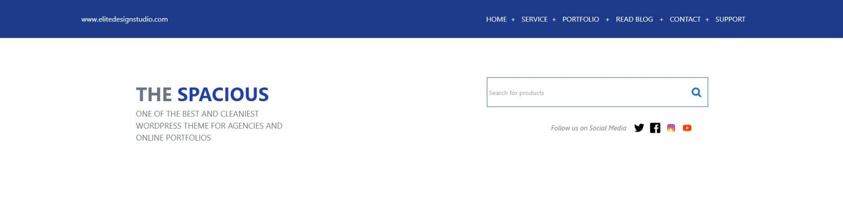

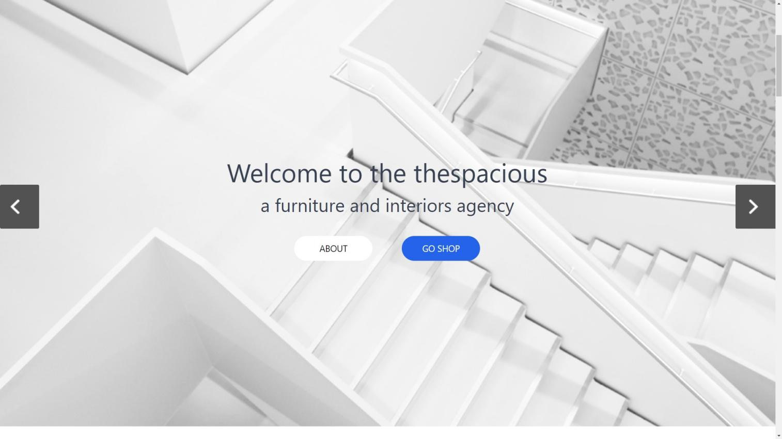

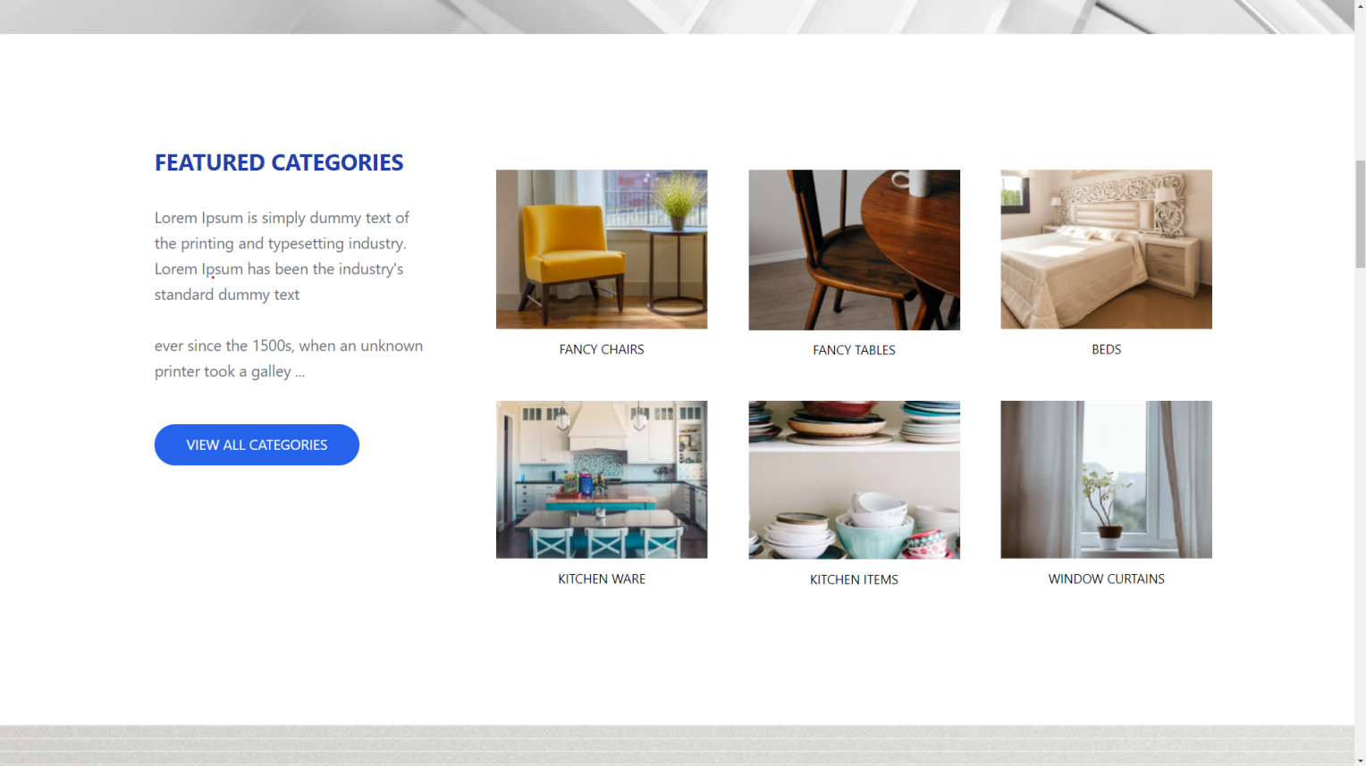

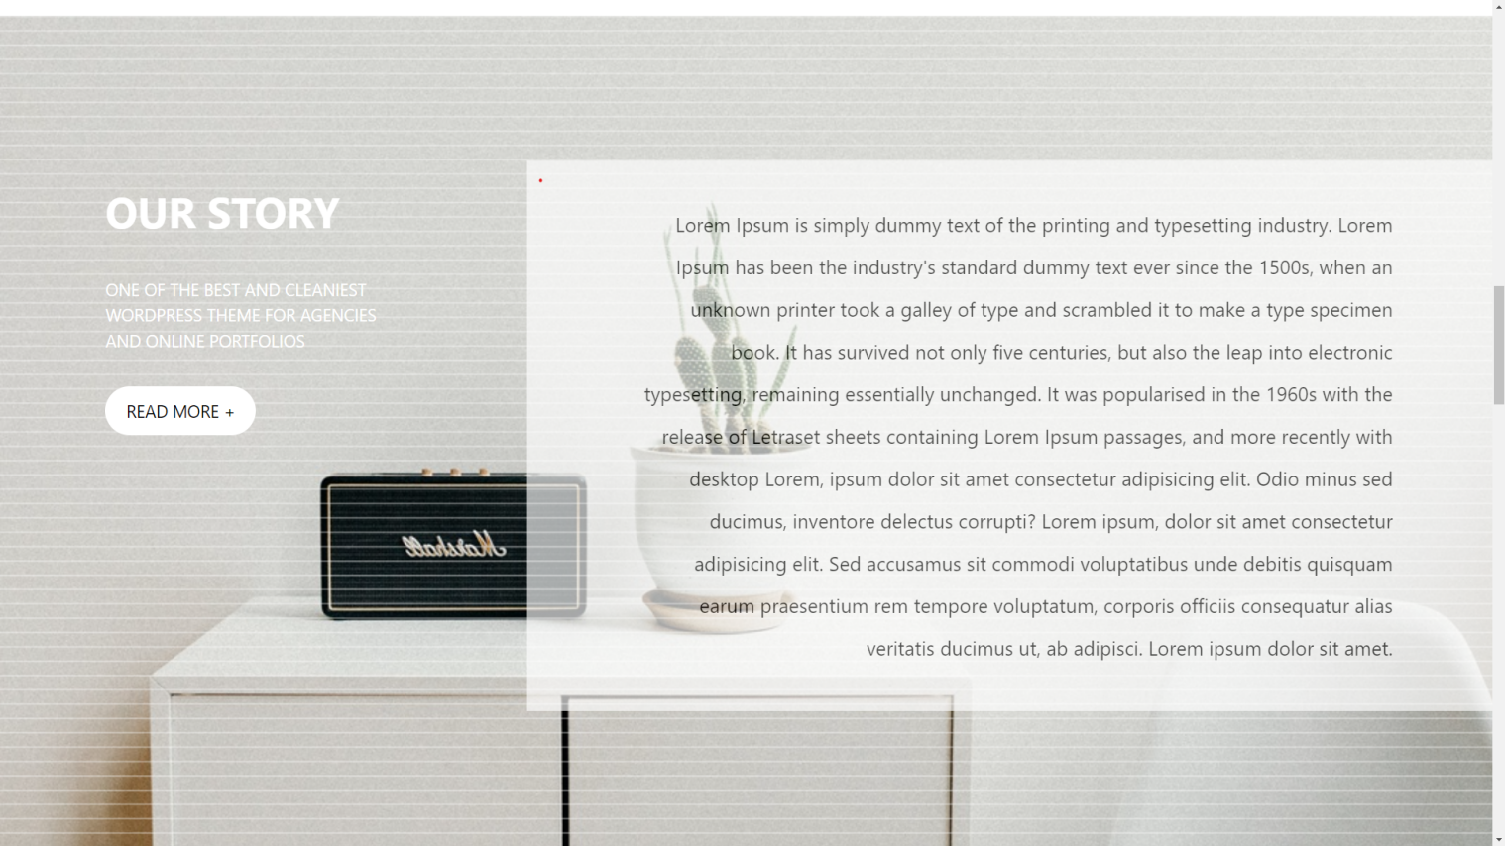

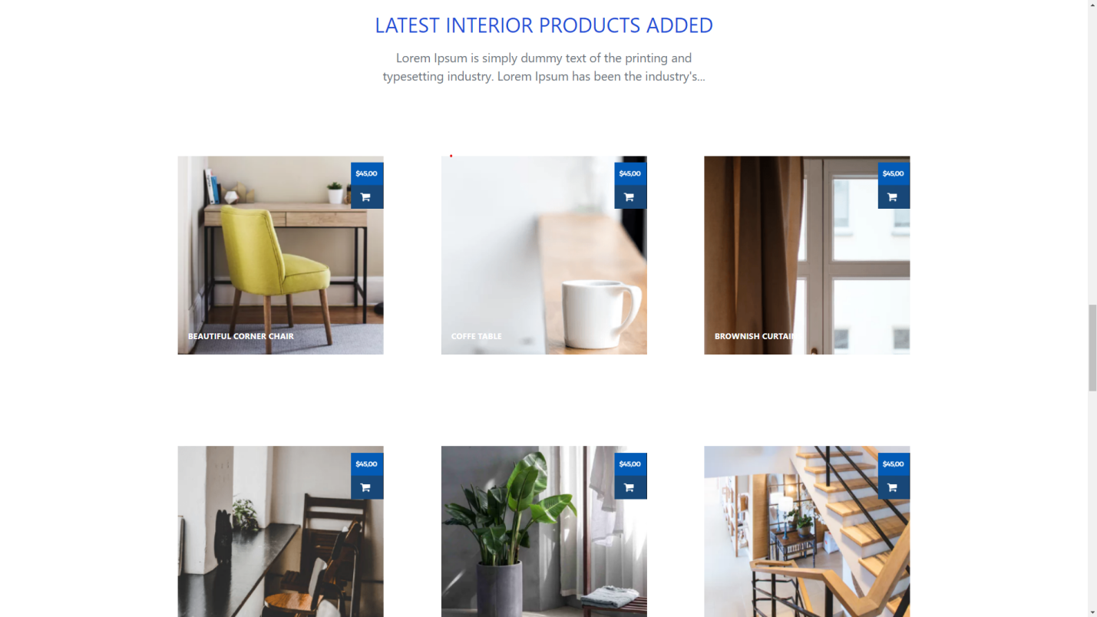

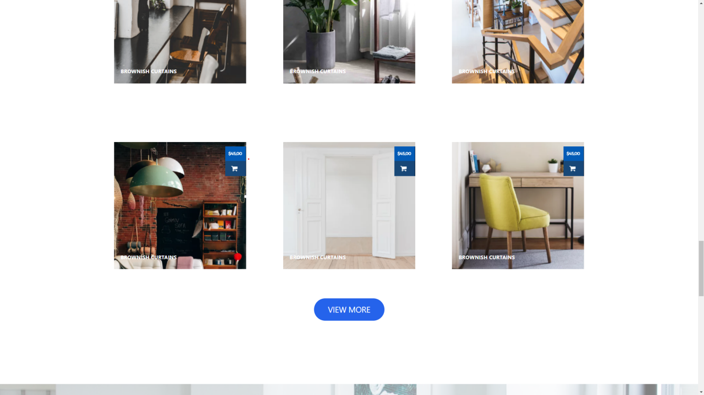

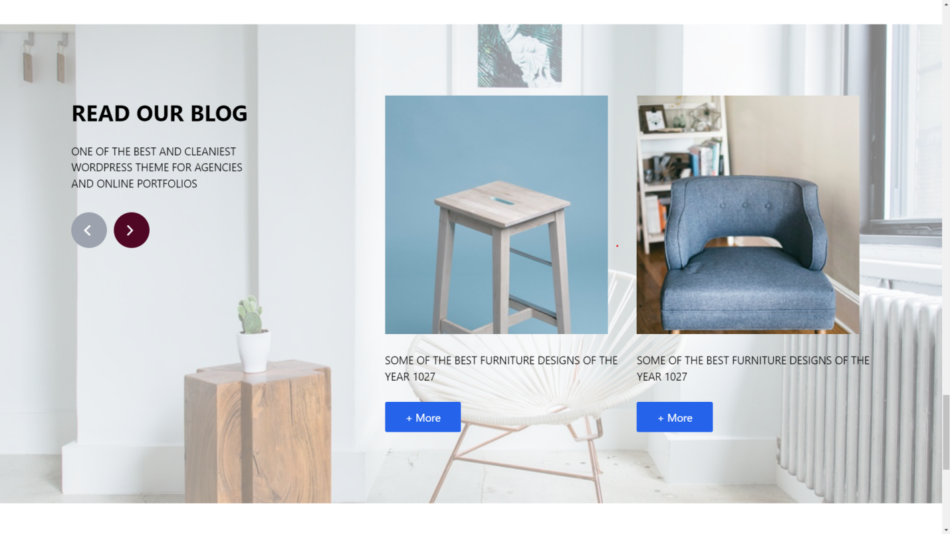

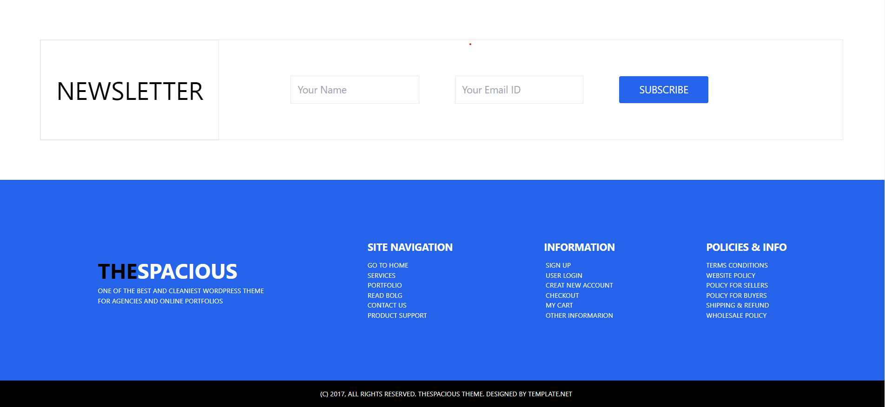

1. **Mobile View**



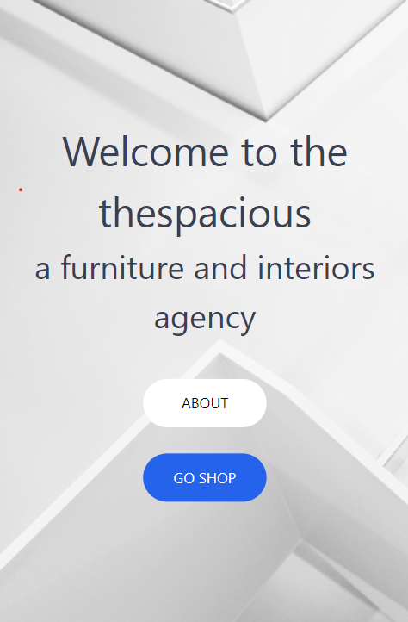

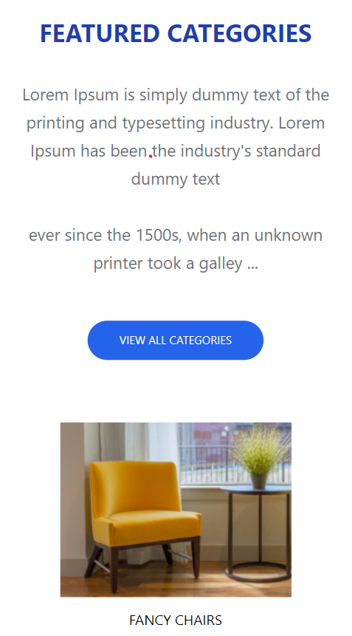

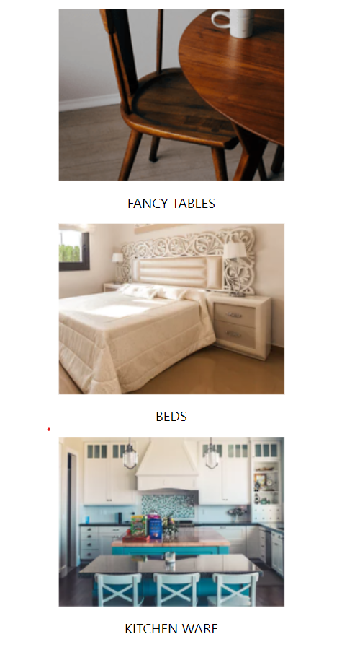

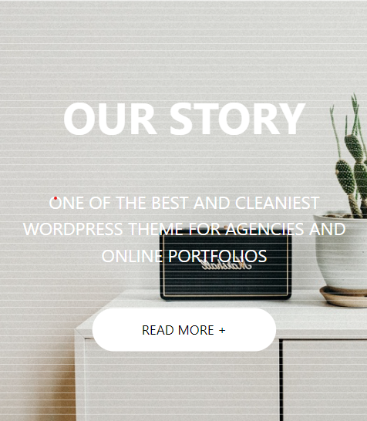

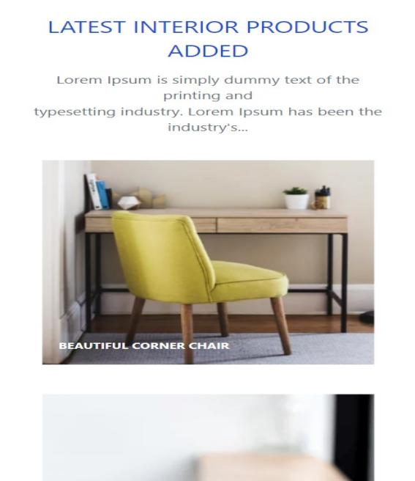

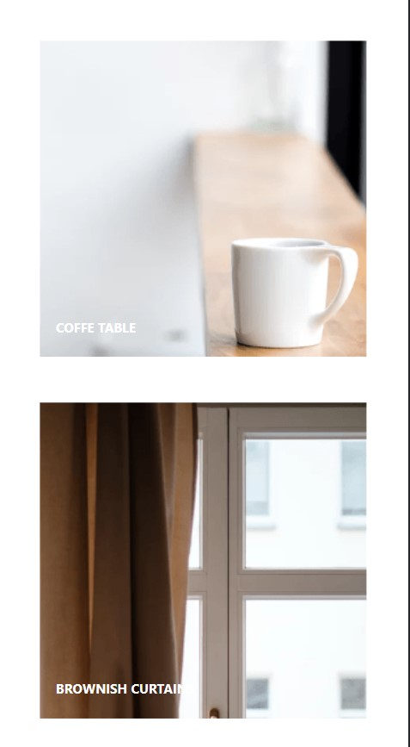

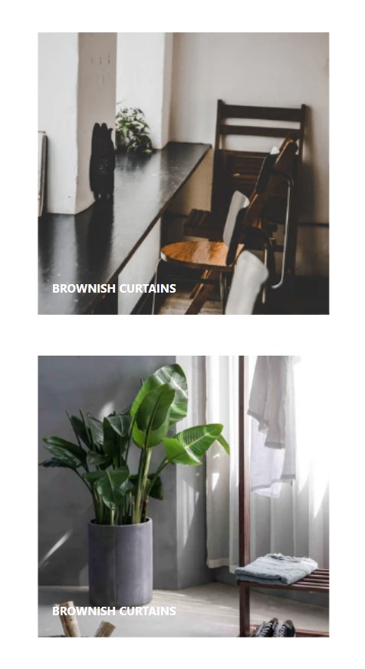

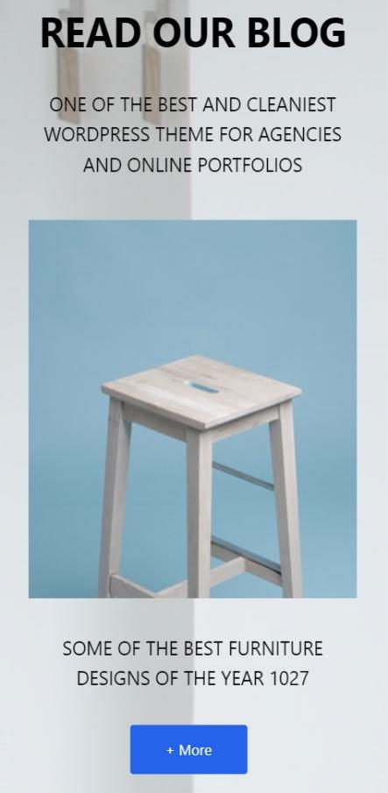

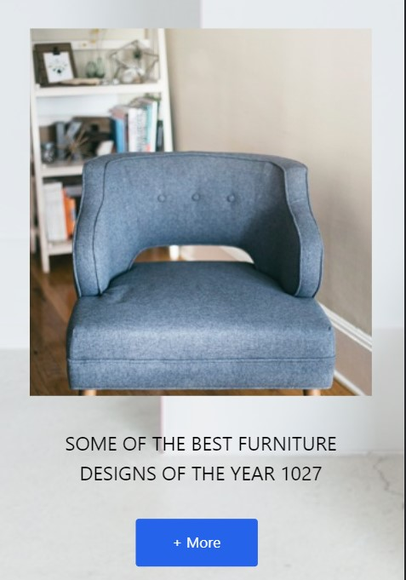

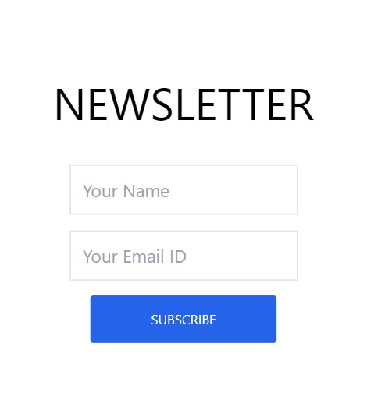

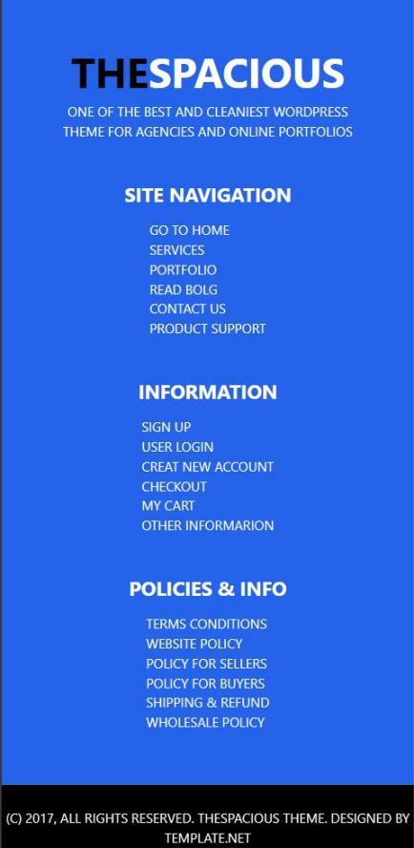

**References**

**Documentation:**

**1. W3Schools: <https://www.w3schools.com/>**

**2. MDN:    <https://developer.mozilla.org/en-US/>**

**3. React Dev: <https://react.dev/>**

**Fonts:**

**Google Fonts: <https://fonts.google.com/>**

**PSD Viewer:**

<https://www.photopea.com/>

**To include Tailwind CSS in our html file :**

<https://tailwindcss.com/>